2013 ACE Critique and Awards Program
NMSU Media Productions — Jeanne Gleason

Monster School Bus  Class 13:  Interactive Multimedia and Web Graphics | 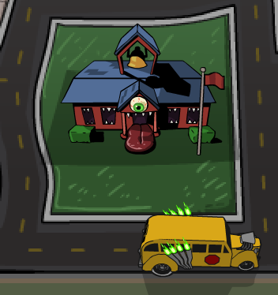
To see the graphics submitted from this game, please visit:
ace.nmsu.edu/2013/mathsnacks/Class13_MSB.html
Overview:
Game graphics used within the online game Monster School Bus are part of NMSU’s Math Snacks initiative funded by the National Science Foundation. Submitted in this category are all graphics, including interface elements, board design, and other thematic elements. All graphics were tested extensively in the NMSU Learning Games Lab with middle school students before determining an art style and variations on the theme ideally suited to this middle school audience. To see graphics entered in this class, use the link above. To play the game click mathsnacks.com/monsterschoolbus.
Of particular interest is the board design and how it changes in each of the four major sections. Similarly important is how the graphic elements give the user visual representation of numbers, seeing them as numerals, as part of a ten-frame (creatively interpreted in a school bus) and as individual items. Note, for example, how smaller aliens make up “half” of a seat, and larger monsters take two seats. This creative interpretation of graphics serves an important role in conceptual understanding of number sense.
Purpose (goals, objectives, need):
Monster School Bus is part of NMSU’s Math Snacks initiative to develop innovative tools for teaching content addressed in the National Common Core mathematics standards. Math Snacks give students, especially those who don't particularly like math, another way to look at math concepts.
Monster School Bus addresses number sense. The graphics within the game are crucial in addressing Common Core Standards for Math, including:
- Understanding numbers, ways of representing numbers, relationships among numbers, and number systems.
- Visualizing numbers as sets and quantities.
- Building new mathematical knowledge through problem solving

Audience:
While this game is designed for middle school content, it has been used successfully with learners in grades 3–8.
Marketing/promotion:
Currently in research phase, use of Monster School Bus in randomized control trials has begun. At this time, it is being used by teachers and children engaged in research trials and by those who have been exposed to the product through presentations, articles in journals, during summer teacher training programs, and through online curriculum portals like Edmodo.com. In anticipation of widespread release of the tools in 2014, NMSU is developing a marketing and promotion plan through NMSU’s Math Snacks outreach initiative, supported by a full-time NMSU staff member. The sustainability and commercialization of the products is also being considered, building on current Math Snacks distribution partnerships with BrainPop, the National Council of Teachers of Mathematics (NCTM), and a successfully funded NSF I-Corp proposal to investigate commercialization.
Role of each entrant for the project:
All work, including animation, programming and instructional design, was produced in NMSU’s Media Productions studios. The specific team for Monster School Bus is listed in credits. The overall team includes animators, artists, programmers, designers, content specialists, writers and editors.
Extent to which project met goals and objectives:
Each game is pilot tested throughout development. Beginning in the fall of 2012, the Math Snacks team began initial controlled evaluation using random trials in school and after-school settings. The results of this research have not yet been analyzed, but anecdotal reports from teachers and the pilot testing trials suggest that Monster School Bus is effective at teaching key concepts. Throughout the extensive user testing, the game was played by many different groups of kids, yielding suggestions and resulting in changes to gameplay and character design.
How diversity was incorporated into entry:
New Mexico has a Hispanic-majority public school student body populations and has long been considered a bellwether for future student body characteristics in the United States. Without competency in mathematics, students – particularly those in low-income areas, English language learners and students with special needs – are limited in their course and career options in STEM fields. Math Snacks has a proven track record of creating innovative products for all learners, with a design approach that involves underrepresented students throughout the design, development and testing phases of the products. Products have been tested extensively with diverse students and been reviewed by independent quality assurance panels annually, with specific attention paid to accessibility by diverse audiences and cultural sensitivity. Funders, such as the National Science Foundation, have found that interactive modules that test well with New Mexican students are often highly effective in increasing readiness to grasp STEM-related concepts within a national student population.
Other information:
Monster School Bus is part of a much larger Math Snacks program that includes not only the games and animations, but also teacher and learner guides.

