2013 ACE Critique and Awards Program
NMSU Media Productions — Jeanne Gleason

Teaching with Math Snacks Professional Development Materials  Class 41:  Technology Education | 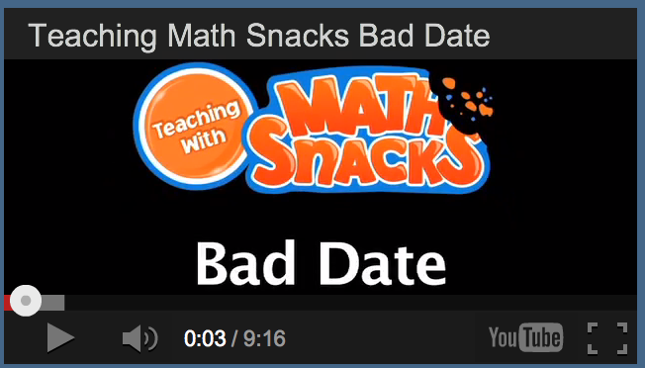
To see the technology education components, including videos, website and supplemental learning tools, please visit ace.nmsu.edu/2013/mathsnacks/Class41MS.html
Overview:
The Math Snacks project is extensive, including videos, games and tools. The entire project is available at MathSnacks.com. For this entry, we are submitting the educational package used to guide teachers in using the technology in their classroom. That includes a Teaching with Math Snacks video for each snack (demonstrating how to integrate that animation with other teaching strategies) and print guides for learning (Teacher's Guide, Learner's Guide and Comic Book Transcript). The entire suite of tools is accessible on the Teaching with Math Snacks site at mathsnacks.com/teacher.php, but the materials are itemized for your convenience at ace.nmsu.edu/2013/mathsnacks/Class41MS.html
Math Snacks includes animations, games and learning tools for middle school learners, addressing gaps in conceptual understanding of math concepts. While the tools have demonstrated appeal to learners, their impact is much greater when used in the classroom, with guiding questions, supplemental hands-on activities, and frameworks for integration with other teaching methods. Professional development of teachers, helping them integrate Math Snacks tools with their instruction, optimizes the Snacks’ utility. To that end, a suite of tools was created to educate teachers in using the Math Snacks technology.
Purpose (goals, objectives, need):
NMSU’s Math Snacks initiative was funded by the National Science Foundation to develop innovative tools for teaching content addressed in the National Common Core mathematics standards. The purpose of the Teaching with Math Snacks materials is to guide teachers in using the tools effectively. That includes pedagogical strategies; such as, “watch the animations twice – once for fun – and then a second time, pausing for discussion, as well as activities that extend the learning.”

Researchers observed classrooms where Math Snacks were being used, and then created the Math Snacks Summer Camp, an innovative development process where teachers developed curriculum around the Math Snacks in the mornings, then tested their ideas with mid school students in the afternoon, revised their approach, and repeated the next day. Through this process, team members identified best strategies for using the Math Snacks, and shaped the printable Teacher’s Guides and Learner’s Guides. The video team then created shoots where expert teachers taught using the Math Snacks, then edited the videos to capture best practices and talking points to explain the approach teachers used.
Audience:
While Math Snacks is designed for middle school, it is used across New Mexico in grades 3–8. The audience for the Teaching with Math Snacks materials are math teachers of 6th and 7th grade students.
Marketing/promotion:
Currently in research phase, almost all Math Snacks are completed or in beta, and use of the tools in randomized control trials has begun. At this time, the tools are being used by those teachers and children engaged in research trials and by those who have been exposed to the product through presentations, articles in journals, during summer teacher training programs, and through online curriculum portals like Edmodo.com. In anticipation of widespread release of the tools in 2014, NMSU is developing a marketing and promotion plan through NMSU’s Math Snacks outreach initiative, supported by a full-time NMSU staff member. The sustainability and commercialization of the products is also being considered, building on current Math Snacks distribution partnerships with BrainPop, the National Council of Teachers of Mathematics (NCTM), and a successfully funded NSF I-Corp proposal to investigate commercialization.
Role of each entrant for the project:
All work, including animation, programming and instructional design, was produced in NMSU’s Media Productions studios with content and pedagogical expertise from NMSU’s College of Education.
Extent to which project met goals and objectives:
Each product of the Math Snacks project is pilot tested throughout development. The results of research on tools have not yet been analyzed, but anecdotal reports from teachers and the pilot testing trials suggest that Math Snacks is highly effective at teaching key concepts.
In an important pilot study, researchers compared teachers using a structured protocol (“On Day 1, use this tool, ask these questions, and follow with this activity”) to teachers exposed to Math Snacks products and encouraged to use them on their own (“Use the Math Snacks animations some time during the first six weeks.”) Researchers found no difference in the different approaches of teachers as to the impact on students, and believe it is because most of the teachers in the study had been exposed to the professional development strategies emphasized in the teaching materials. In short, teachers didn’t need a specific protocol, because they understood enough of the strategy of using Math Snacks to devise their own approach based on best practices.
How diversity was incorporated into entry:
New Mexico has a Hispanic-majority public school student body populations and has long been considered a bellwether for future student body characteristics in the United States. Math Snacks has a track record of creating innovative products for all learners, with a design approach that involves underrepresented students throughout the design, development and testing phases of the products.

