2013 ACE Critique and Awards Program
NMSU Media Productions — Jeanne Gleason

Math Snacks – animations, games, support videos, website and supplemental materials
Class 34:
Educational Package
To see all components of the Math Snacks training program, please visit
mathsnacks.com
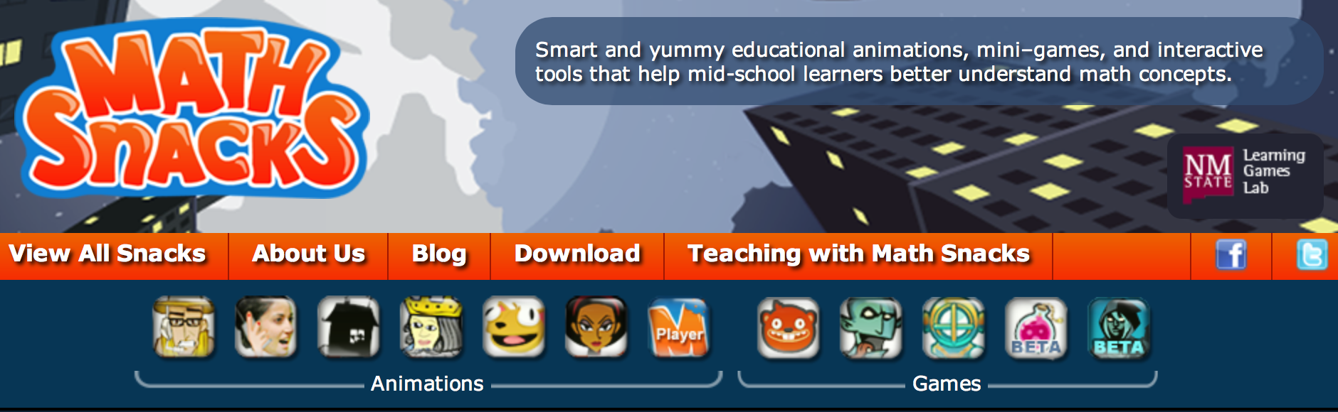
Overview:
The Math Snacks project is extensive, including animations, games and tools, as well as a complete site for teachers called Teaching with Math Snacks. The entire project (six animations, five games, printable guides, downloadable apps, teacher support videos and supplemental tools) is available at MathSnacks.com. Designed for middle school learners, it addresses gaps in conceptual understanding of math concepts and the objectives from the National Common Core mathematics standards. Math Snacks is not designed to replace instruction, but rather to supplement it by making math more accessible.
Products have been developed over a three-year period during which researchers, math content experts, instructional designers, and design professionals worked together to craft the animations, games and learning materials. While the tools have demonstrated appeal to learners, their impact is much greater when used in the classroom, with important guiding questions, supplemental hands-on activities, and frameworks for integration with other teaching methods. Critical to the success of Math Snacks is the professional development of teachers using the tools, helping them integrate Math Snacks tools with their instruction.
NMSU’s Math Snacks initiative was funded by the National Science Foundation to develop innovative tools for teaching content addressed in the National Common Core mathematics standards. Math Snacks give students, especially those who don't particularly like math, another way to look at math concepts.

Purpose (goals, objectives, need):
Team researchers analyzed standardized mathematics test results from over 24,000 students in 400 classrooms, identifying the gaps in learning. They observed classroom instruction and interviewed students and teachers to discover why commonly missed items were misunderstood. The Math Snacks Learning Objectives grew out of these findings as well as the new National Core Standards. Development of each element created for Math Snacks was carefully measured against this extensive list of objectives.
Audience:
While Math Snacks is designed for middle school, it is used across New Mexico in grades 3–8. Middle school teachers say that Math Snacks is particularly helpful when students are slow to master more complex mathematics understanding because they failed to grasp key math concepts in grade school. The Snacks revisit those topics and give students the necessary building blocks to build understanding and move forward. The audience for the Teaching with Math Snacks materials is math teachers of 6th and 7th grade students. The Snacks themselves can be used as part of classroom instruction, or independently by youth.
Marketing/promotion:
Currently in research phase, almost all Math Snacks are completed or in beta, and use of the tools in randomized control trials has begun. At this time, the tools are being used by teachers and children engaged in research trials and by those who have been exposed to the product through presentations, articles in journals, during summer teacher training programs, and through online curriculum portals like Edmodo.com. In anticipation of widespread release of the tools in 2014, NMSU is developing a marketing and promotion plan through NMSU’s Math Snacks outreach initiative, supported by a full-time NMSU staff member. The availability of many of these Math Snacks on the Internet, iPhone and iPad makes it possible for students to enjoy Math Snacks games and animations during non-school time as well as in class. The sustainability and commercialization of the products is also being considered, building on current Math Snacks distribution partnerships with BrainPop, the National Council of Teachers of Mathematics (NCTM), and a successfully funded NSF I-Corp proposal to investigate commercialization.
Role of each entrant for the project:
All work, including animation, programming and instructional design, was produced in NMSU’s Media Productions studios with content and pedagogical expertise from NMSU’s College of Education. The specific team for each Snack is listed in credits.
Extent to which project met goals and objectives:
Each product of the Math Snacks project is pilot tested throughout development. The results of research on tools have not yet been analyzed, but anecdotal reports from teachers and the pilot testing trials suggest that Math Snacks is both highly effective at teaching key concepts and also so much fun that kids forget they are learning math.
How diversity was incorporated into entry:
New Mexico has a Hispanic-majority public school student body populations and has long been considered a bellwether of America’s future student body characteristics. Without competency in mathematics, low-income students, English language learners and students with special needs are limited in their career options in high paying fields. Math Snacks has a proven track record of creating innovative products for all learners, with a design approach that involves underrepresented students throughout the design, development and testing phases of the products. Products have been tested extensively with diverse students and reviewed by independent quality assurance panels annually, with specific attention paid to accessibility by diverse audiences and cultural sensitivity.

