2013 ACE Critique and Awards Program
NMSU Media Productions — Jeanne Gleason

Teaching with Math Snacks Professional Development Materials  Class 33:  Informational or Non-Credit Video Production | 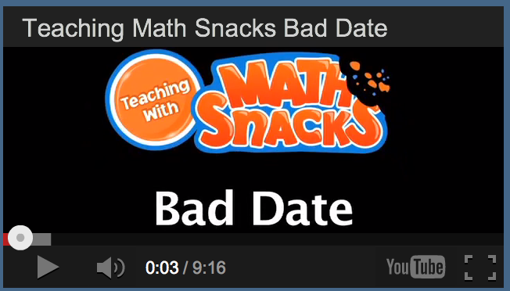
To see the teaching videos, please visit ace.nmsu.edu/2013/mathsnacks/Class33_MS.html
Overview:
The Math Snacks project is extensive, including videos, games and tools. The entire project is available at MathSnacks.com. For this entry, we are submitting the videos used to guide teachers in how to use Math Snacks animations in their classroom. That includes a "Teaching with Math Snacks" video for each snack (which demonstrates how to integrate that animation with other teaching strategies). The entire suite of tools is accessible on the Teaching with Math Snacks site at mathsnacks.com/teacher.php, but the Teaching with Math Snacks videos are itemized for your convenience at: http://medios.nmsu.edu/ace/list
Math Snacks includes animations, games and learning tools for middle school learners, addressing gaps in conceptual understanding of math concepts. While the tools have demonstrated appeal to learners, their impact is much greater when used in the classroom, with important guiding questions, supplemental hands-on activities, and frameworks for integration with other teaching methods. Critical to the success of Math Snacks is the professional development of teachers using the tools, helping them integrate Math Snacks tools with their instruction. To that end, a suite of videos was created to educate teachers in using the Math Snacks technology. In most cases, the videos on Teaching with Math Snacks are longer than the animations they reference.
Purpose (goals, objectives, need):
NMSU’s Math Snacks initiative was funded by the National Science Foundation to develop innovative tools for teaching content addressed in the National Common Core mathematics standards. Math Snacks give students, especially those who don't particularly like math, another way to look at math concepts. The purpose of the Teaching with Math Snacks materials is to guide teachers in using the tools effectively. That includes pedagogical strategies, such as, “watch the animations twice – once for fun – and then a second time, pausing for discussion,” as well as activities that extend the learning.
Researchers observed classrooms where Math Snacks were being used, and then created the Math Snacks Summer Camp, an innovative development process where teachers developed curriculum around the Math Snacks in the mornings, then tested their ideas with mid school students in the afternoon, revising their approach, and repeating the next day. Through this process, team members identified best strategies for using the Math Snacks, and shaping the printable Teacher’s Guides and Learner’s Guides. The video team then created shoots where expert teachers taught using the Math Snacks, then edited the videos to capture best practices and talking points to explain the approach teachers used.
Audience:
While Math Snacks is designed for middle school, in New Mexico it’s used in grades 3–8. The audience for the Teaching with Math Snacks materials is math teachers of 6th and 7th grade students.
Marketing/promotion:
Almost all Math Snacks are completed or in beta, and use of the tools in randomized control trials has begun. At this time, the tools are being used by those teachers and children engaged in research trials and by those who have been exposed to the product through presentations, articles in journals, during summer teacher training programs, and through online curriculum portals like Edmodo.com. In anticipation of widespread release of the tools in 2014, NMSU is developing a marketing and promotion plan through NMSU’s Math Snacks outreach initiative, supported by a full-time NMSU staff member. The sustainability and commercialization of the products is also being considered, building on current Math Snacks distribution partnerships with BrainPop, the National Council of Teachers of Mathematics (NCTM), and a successfully funded NSF I-Corp proposal to investigate commercialization.
Role of each entrant for the project:
All work, including animation, programming and instructional design, was produced in NMSU’s Media Productions studios with content and pedagogical expertise from NMSU’s College of Education. The overall team includes videographers, animators, artists, programmers, designers, content specialists, writers and editors. All have contributed in some way to the professional development materials.
Extent to which project met goals and objectives:
Although still in research phase, each product of the Math Snacks project is pilot tested throughout development. In an important pilot study, researchers compared teachers using a structured protocol for using Math Snacks products (“On Day one, use this tool, ask these questions, and follow with this activity”) to teachers exposed to Math Snacks products and encouraged to use them on their own (“Use the Math Snacks animations some time during the first six weeks”). Researchers found no difference between the different approaches of teachers in the impact on students and believe it is because most of the teachers in the study had been exposed to the professional development strategies emphasized in the teaching materials. In short, teachers didn’t need a specific protocol, because they understood enough of the strategy of using Math Snacks to devise their own approach based on best practices.
How diversity was incorporated into entry:
New Mexico has a Hispanic-majority public school student body populations and has long been considered a bellwether of America’s future student body characteristics. Without competency in mathematics, students – particularly those in low-income areas, English language learners and students with special needs – are limited in their career options in high paying fields. Math Snacks has a proven track record of creating innovative products for all learners, with a design approach that involves underrepresented students throughout the design, development and testing phases of the products. Products have been tested extensively with diverse students and been reviewed by independent quality assurance panels annually, with specific attention paid to accessibility by diverse audiences and cultural sensitivity. Review by the National Science Foundation project found these games are well suited to classrooms with diverse student populations.

