2013 ACE Critique and Awards Program
NMSU Media Productions — Jeanne Gleason

Game Over Gopher  Class 12:  Illustration Single or Series | 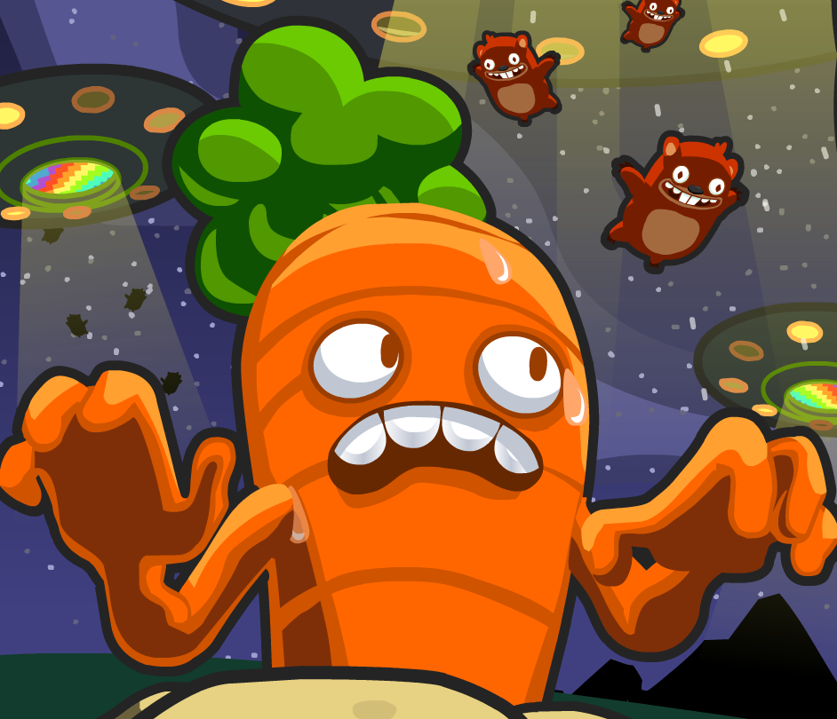
To see the submitted illustrations, please visit
ace.nmsu.edu/2013/mathsnacks/Class12_GOG.html
Overview:
These illustrations were used in characters and design elements within the online game Game Over Gopher – part of NMSU’s Math Snacks initiative funded by the National Science Foundation. The illustrations were tested extensively in the NMSU Learning Games Lab with middle school students before determining an art style and variations on the theme ideally suited to this middle school audience. The game is playable at mathsnacks.com/GameOverGopher .
Purpose (goals, objectives, need):
Game Over Gopher is part of NMSU’s Math Snacks initiative funded by the National Science Foundation to develop innovative tools for teaching content addressed in the National Common Core mathematics standards. Math Snacks give students, especially those who don't particularly like math, another way to look at math concepts.
Game Over Gopher addresses coordinate points on a plane but feels like a tower defense game. Because NMSU’s creative team members are avid game players themselves, their goal is to create games that are fun enough to play again and again: the illustration and character design is a key part of that.
Audience:
While this game is designed for middle school content, it has been used successfully with learners in grades 3–8.
Marketing/promotion:
Currently in research phase, almost all Math Snacks are completed or in beta, and use of the tools in randomized control trials has begun. At this time, the website is being used by teachers and children engaged in research trials and by those who have been exposed to the product through presentations, articles in journals, during summer teacher training programs, and through online curriculum portals like Edmodo.com. In anticipation of widespread release of the tools in 2014, NMSU is developing a marketing and promotion plan through NMSU’s Math Snacks outreach initiative, supported by a full-time NMSU staff member. The availability of many of these Math Snacks on the Internet, iPhone and iPad makes it possible for students to enjoy Math Snacks games and animations during non-school time as well as in class. The sustainability and commercialization of the products is also being considered, building on current Math Snacks distribution partnerships with BrainPop, the National Council of Teachers of Mathematics (NCTM), and a successfully funded NSF I-Corp proposal to investigate commercialization.
Role of each entrant for the project:
All work, including illustration, animation, programming and instructional design, was produced in NMSU’s Media Productions studios by a team of professionals. The specific team for Game Over Gopher is listed in credits. The overall team includes animators, artists, programmers, designers, content specialists, writers and editors. All have contributed in some way to the graphics development.
Extent to which project met goals and objectives:
Each game is pilot tested throughout development. Beginning in the fall of 2012, the Math Snacks team began initial controlled evaluation using random trials in school and after-school settings. The results of this research have not yet been analyzed, but anecdotal reports from teachers and the pilot testing trials suggest that Game Over Gopher is effective at teaching key concepts. Throughout the extensive user testing, the game was played by 20 different groups of kids, yielding suggestions and resulting in changes to gameplay and character design. The character design is frequently mentioned as one of the best aspects of the game. In fall, 2012, an external quality assurance committee reviewed the game, commenting extensively on the quality of the graphics.
How diversity was incorporated into your entry:
New Mexico has a Hispanic-majority public school student body populations and has long been considered a bellwether for future student body characteristics in the United States. Without competency in mathematics, students – particularly those in low-income areas, English language learners and students with special needs – are limited in their course and career options in STEM fields. Math Snacks has a proven track record of creating innovative products for all learners, with a design approach that involves underrepresented students throughout the design, development and testing phases of the products. Products have been tested extensively with diverse students and been reviewed by independent quality assurance panels annually, with specific attention paid to accessibility by diverse audiences and cultural sensitivity. Funders, such as the National Science Foundation, have found that interactive modules that test well with New Mexican students are often highly effective in increasing readiness to grasp STEM-related concepts within a national student population.
Other information:
Game over Gopher is part of a much larger Math Snacks program that includes not only the games and animations, but also teacher and learner guides, as well as a video of a model lesson showing a teacher using all of the materials. All Math Snacks products are aligned with the Common Core State Standards for Mathematics (CCSSM) and address the CCSSM Mathematical Practices when used as recommended. Math Snacks materials address critical content including number sense, ratio, proportion, measurement, scale factor, and pre-algebra. Some Math Snacks address more than one content area and can be used in a variety of lessons at different grade levels. Characters and artwork have been used across media.

