2013 ACE Critique and Awards Program
NMSU Media Productions — Jeanne Gleason

Don’t Be Gross  Class 14:  Poster |  | To see a higher quality image of the Don’t Be Gross poster, please visit:  ace.nmsu.edu/2013/DBG/Class14_DBG.html
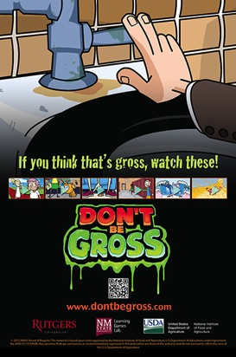 | 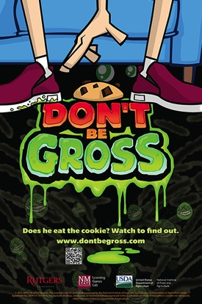 |  | 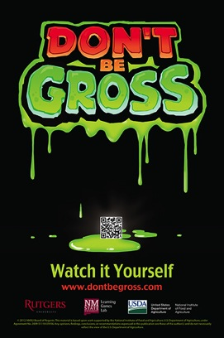
Overview:
These Don’t Be Gross posters were designed as part of an in-school food safety campaign, raising awareness among teens about actions they take each day that are unsafe and about positive steps they can take to prevent illness. The logo played a key role in our initial awareness outreach in the schools and was used on humorous posters, wristbands, temporary tattoos, soap case key chains and online animated videos. We conducted extensive formative evaluation to find a slogan ideally suited to this middle school youth audience and to design a logo that matched its appeal.
Because research shows the most powerful way to reach this age group is through peer networks and social norms, the goal of the Don’t Be Gross campaign was to have the animated videos, concept and logo phrase “Don’t Be Gross” go viral through students posting on their favorite social media sites. Statistics are being collected and compared by schools.

Purpose (goals, objectives, need):
The Don’t Be Gross posters are part of a USDA grant project, with all media tools produced by NMSU’s Media Productions and outreach delivered by Rutgers University in New Jersey middle schools. The campaign was based on preliminary research into the role and importance of peer networks and social norms on food safety behaviors of middle school youth. The objective was to use viral marketing for distribution of messages by middle school students through their pre-existing social networks. The project seeks to create social norms within the student body deeming certain behaviors really gross, such as sharing water bottles, not washing hands properly or eating food that fell on the floor. By establishing a norm of what is gross, visual storytelling may change behavior more efficiently and permanently than other, more traditional forms of education. The posters were key in meeting these objectives by helping students to internalize the social “grossness” of habits the campaign was targeting.
Audience:
The pilot schools included 13 middle schools in New Jersey, with formative evaluation conducted both in New Jersey and in NMSU’s Learning Games Lab in New Mexico. Secondary audiences expanded to include the members of the students’ social networks as they posted links and animated videos to their social media, such as Facebook, Twitter, Pinterest, or Google+. YouTube data of hits on these animated videos showed the audience expanded far outside of the school community to viewers across the country.
Marketing/promotion:
Don’t Be Gross has a robust marketing and promotional plan through 13 New Jersey schools during the initial research phase. The posters, wristbands, and other campaign tools were widely posted and distributed throughout the schools on a staggered basis, to allow researchers to analyze the hit data of the animated videos on YouTube based on school release dates, and to measure behavioral change (such as use of soap in school bathrooms).
Role of each entrant for the project:
All media for this campaign, including the posters, were designed in New Mexico State University’s Media Productions Studios by a team of animators, programmers, and instructional designers and a formative evaluation specialist.
Extent to which project met goals and objectives:
The concept, the posters and all the media underwent extensive formative evaluation conducted both in New Jersey and in NMSU’s Learning Games Lab in New Mexico. This formative evaluation found that the poster designs were ideally suited to meet the project’s goals and objectives. The statistical data and conclusions from the 13 middle school test sites are still being evaluated by Rutgers University and have not yet been published. However, the researchers indicate that the results were positive.
How diversity was incorporated into your entry:
New Jersey and New Mexico are ideal partners and well suited for developing media for diverse audiences. New Jersey has a highly diverse population, with 15% of residents self-identified as Black and 8% as Asian. Nearly 18% of the New Jersey population was born outside the United States. New Mexico is ideally suited for development targeting the Hispanic and Native American populations: with 47% self-identified as Hispanic in the 2010 Census (highest percentage of Hispanic residents of any state) and 10% as Native American (third highest in the nation).

